SAS LOGISTIC REGRESSION Model Result:

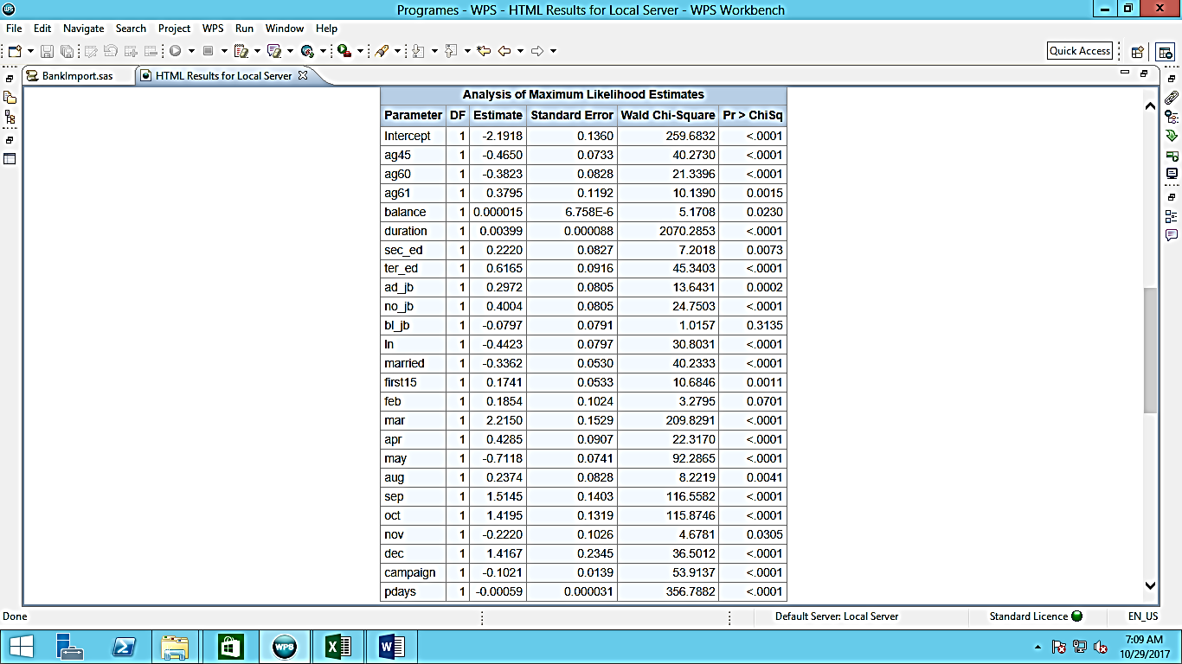

The above result window shows all the parameters that are significant predictors in the model. Business understanding is required to understand the significance of these parameters. It can be seen that age is an important factor. People having higher education and better jobs are more likely to say yes to a direct marketing offer.

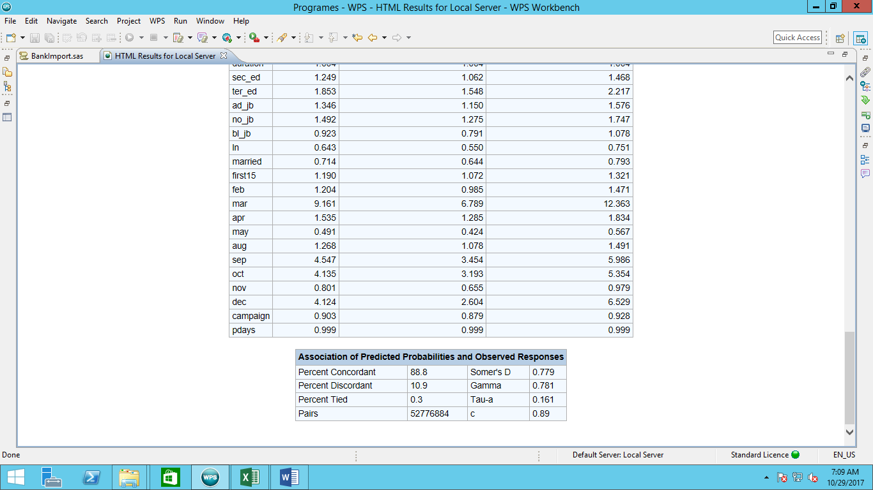

Fig 1 – Concordance Table

Fig 2 – Gain Chart

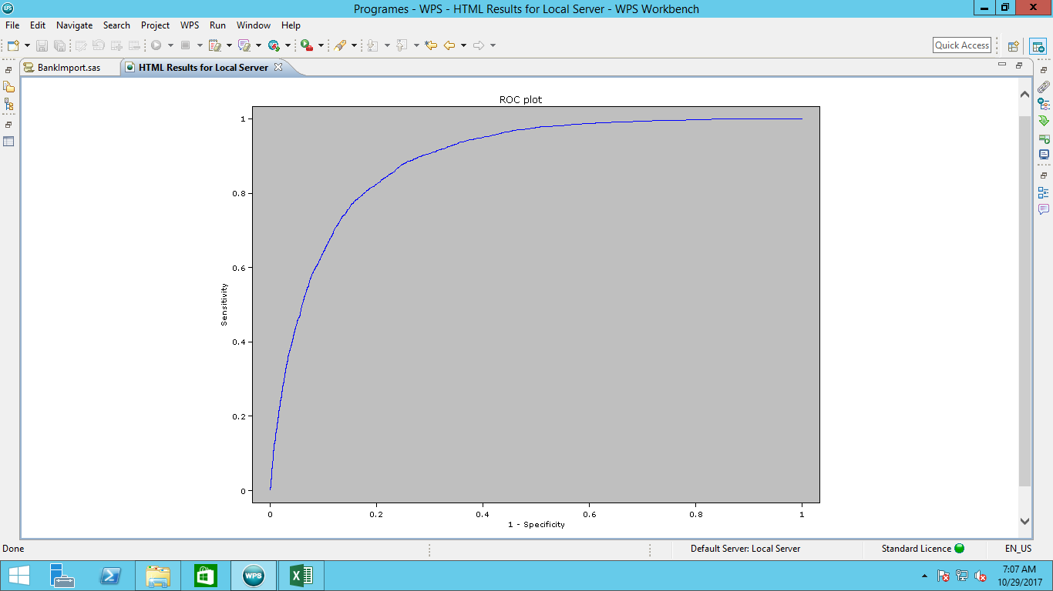

Fig 3 – ROC curve.

Concordance, Gain chart and Roc curve are used to validate the model accuracy and fit. Higher is the percent concordant better is the model. A better model should have a good lift in the gain chart. And the above Roc curve is an indicator of a good model.